Name:
School:
Your role and responsibility in the school:
Years of Teaching Experience:
Telephone:
Email:
Address:
To Know You Better
- Please list five words that you would use to describe yourself:
a.
b.
c.
d.
e.
2. What is the one change that you have been working on in the last 2 years in your classroom/school? What has worked for you? What are the challenges you are facing in bringing the desired change?
Type your answer here

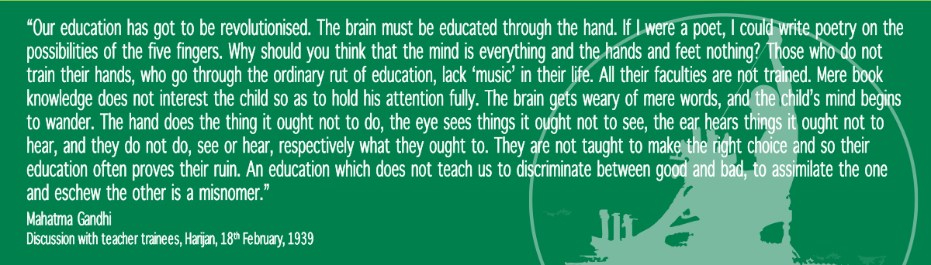
3. What are the three most important challenges that you face as an educator?
Type your answer here

4. How are you feeling about attending the learning Expedition for Educators?
a. Nervous b. Not sure c. Ok d. Ready e. Excited
Type your answer here

5. What are the things that you are looking forward to in the Learning Expedition?
Type your answer here

6. What would you like to know more about the Learning Expedition?
Type your answer here

Payment Details
Cheque No. / Demand Draft No.:
Bank:
Amount (Rupees):

